Fruits Shop E-commerce Web Application
Name : Vrinda M
Batch Name : Python Full Stack 30
Project Topic : Fruits shop E commerce web application
Date : 20/11/2023
Project Overview:
The Fruits Shop E-commerce Website is developed using the Django framework with Python, aiming to provide a robust online platform for buying and selling fresh fruits. The project focuses on enabling online fruit shopping, ensuring an efficient user experience, and implementing user registration and management features.
Project Objectives:
- Enable Online Fruit Shopping:
  - Provide users with a user-friendly interface to browse and purchase a diverse range of fresh fruits online.
- Efficient User Experience:
  - Create an intuitive and responsive website design for a seamless and enjoyable shopping experience across various devices.
- User Registration and Management:
  - Implement a secure user registration system for customers to create accounts, manage profiles, and track order history.
Technology Stack:
- Front-end: HTML5, CSS3, JavaScript, Bootstrap5
- Back-end: Python (Django)
- Database: MySQL
Module Description:
- Home Page / Landing Page:
  - Display all products with images, names, and prices.
  - Buttons for adding items to the cart and viewing the product.
  - Login required for adding items to the cart.
  - Search option in the navigation bar.
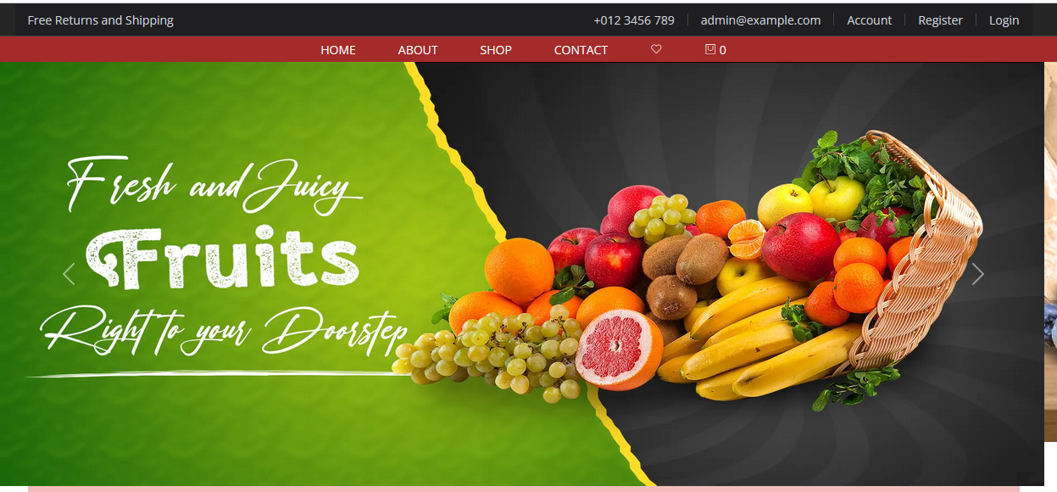
- Register Page:
  - Fields for users to input details such as name, email, password, and additional information.
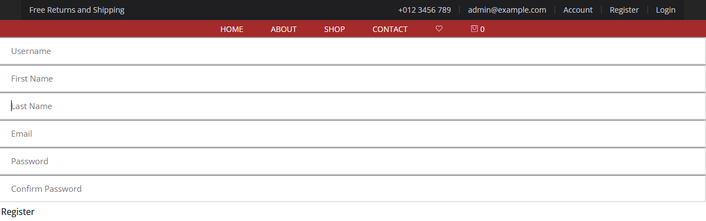
- Login Page
:Users can log in with their username and password.
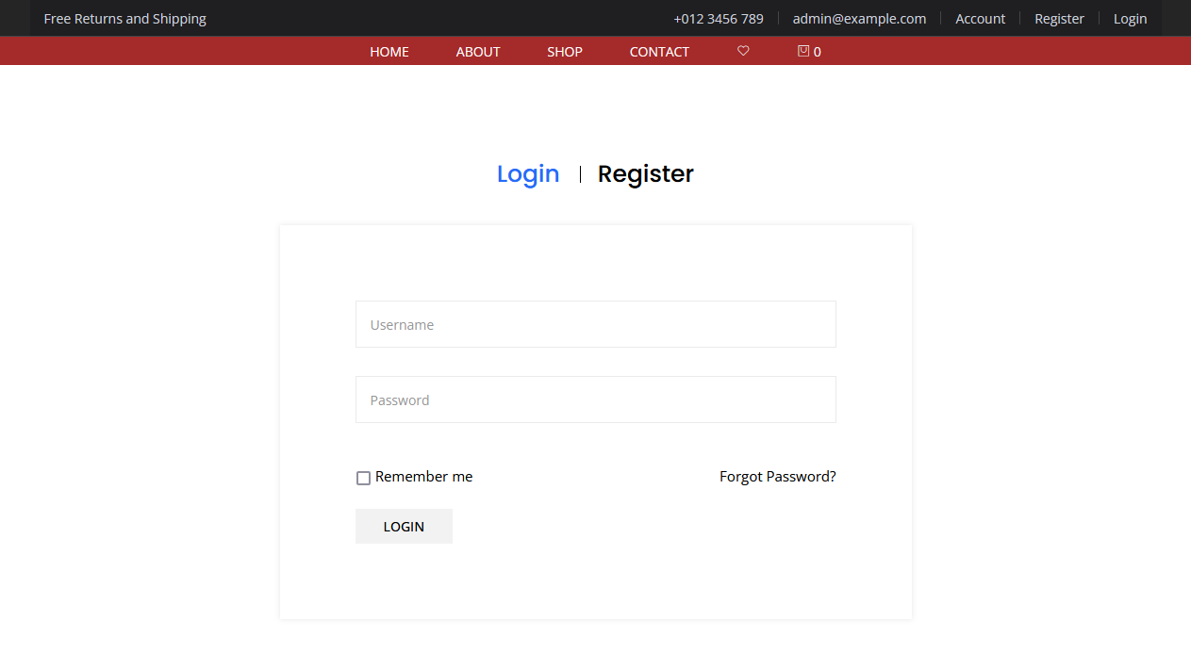

- Cart:
Review and manage items added before proceeding to checkout.

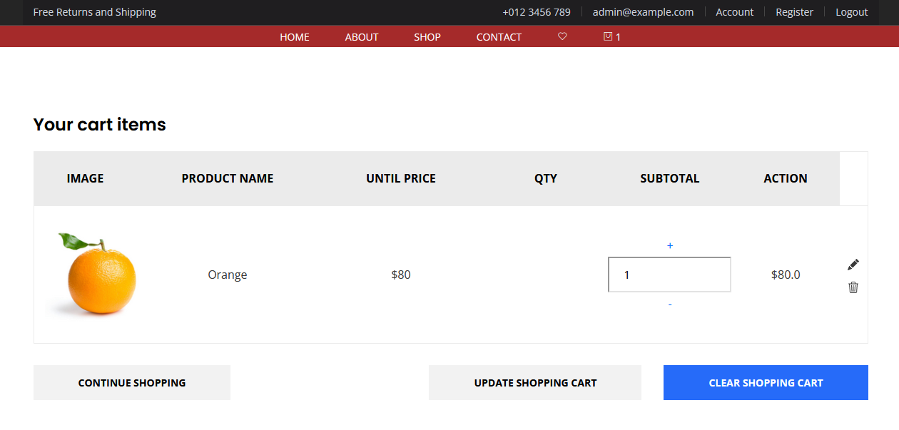

.

- Checkout:
Final stage of the online purchasing process with secure payment options (credit/debit cards, digital wallets).

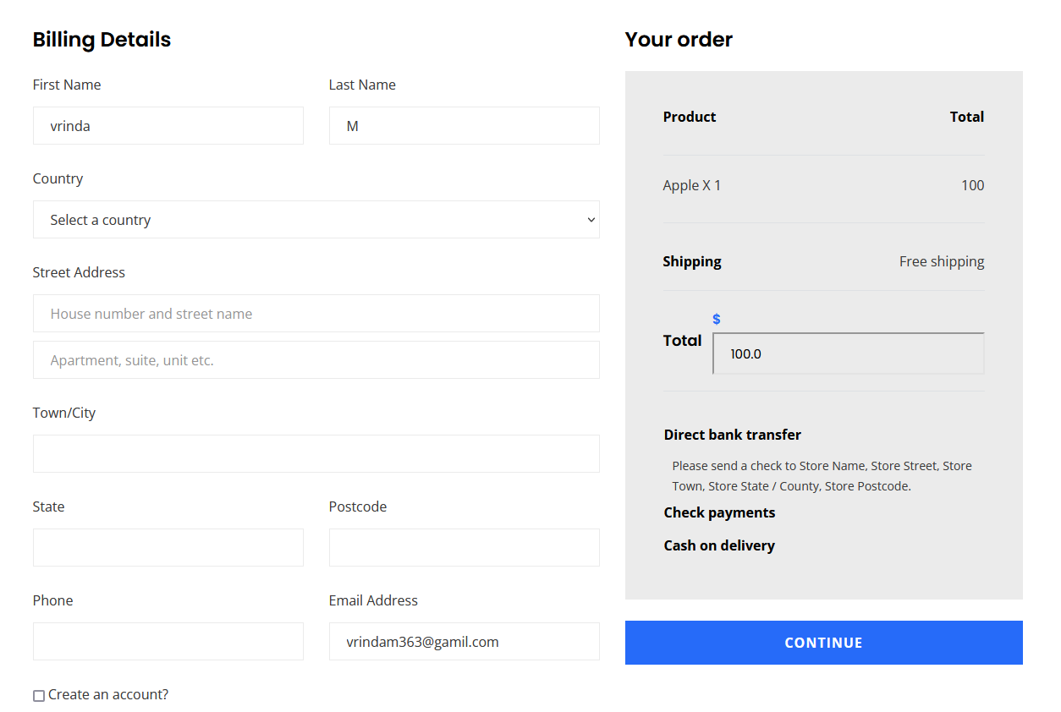

- Contact Us:
Users can ask queries or contact via a form, with separate forms for logged-in and non-registered users.

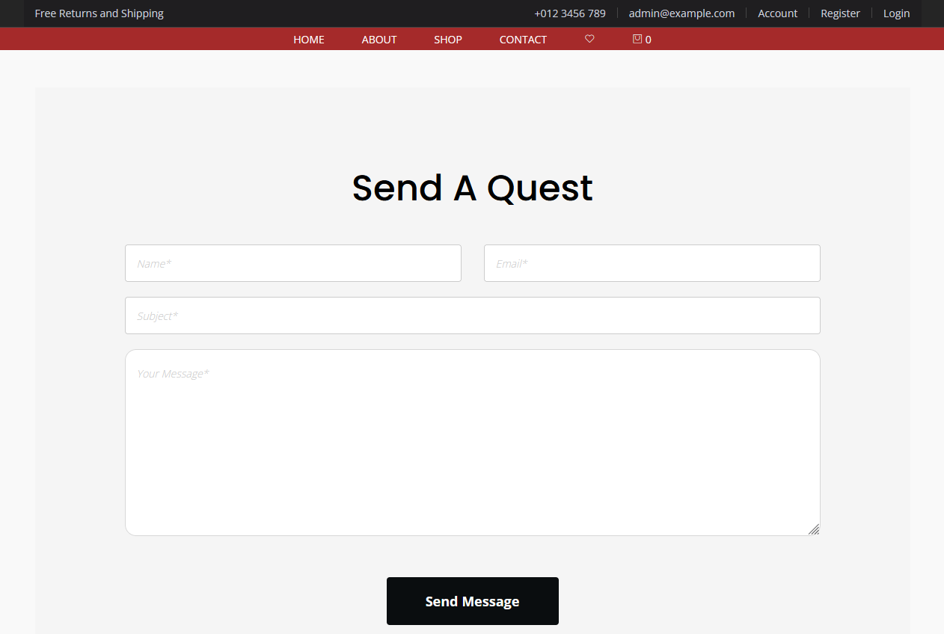

- Payment

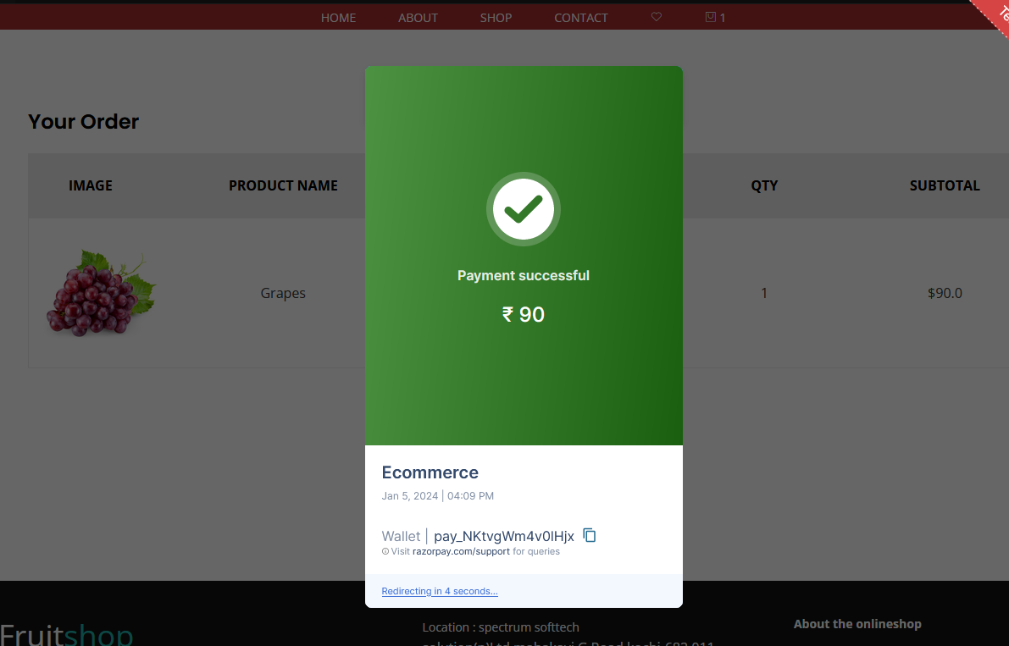

This project structure outlines a comprehensive e-commerce platform for a fruits shop, incorporating essential features for both customers and administrators. It emphasizes user experience, security, and an organized system for managing products and orders.

